# Reading Room Book Search

## **Rationale**

Currently the Reading Room can be navigated by book categories, but there is no easy way for a student to search for books based on a keyword or phrase. When students have trouble finding books about topics they’re interested in, they’re less likely to read on their own. The goal of this feature is to provide students a user-friendly way to search books in the reading room for easier access to books that interest them. Just as importantly, this feature will concentrate on the common case of no results found; instead of a simple message and no books returned, the search feature will recommend books that might interest the student.

## **Overview**

The Reading Room currently shows popular books at the student’s reading level and a navigation bar to explore other categories. In order to find a book based on a specific interest, a student would have to search through the categories, which could be ambiguous for some students. Then they have to navigate through the sub-categories on that page, and finally through the books in the category. This process can be tedious for students, which can then deter them from seeking out books on their own.

Adding a search bar to the reading room makes it easy for a student to find books related to their query. This search bar would use the student’s input to search the titles, keywords, and contents of reading room books, and then display them in an accessible way.

It may be common for students to search terms against our resources that produce an empty result set. In the case that no results are found, the student’s reading history will be used to produce a secondary result set of recommended books, which will be displayed in place of the search results.

## 

## 

## Engineering mockup of the search bar in the Reading Room

## **Functional Requirements**

### Search

A user friendly search bar that searches our current Solr index, as used in Raz-Plus. The search covers titles, keywords, and content. Filtering would ensure the books returned are books already available in the student’s book room. The results are displayed as a row of typical reading room resource cards selected by top weighting assigned by Solr. The number of results will be limited to fit the page as a standard reading room row.

### No Result Recommendations

In the case of no results found during the search, a set of recommended books are returned along with a message like “No results found, but here are some recommendations”.

Recommended books are selected according to the most read genre or theme by the student. Assignment reads would not be included in this equation as it is an attempt to find books the student would like as opposed to books assigned by the teacher. We can order these by top downloads or most favorites.

For example, a student has read 60 books with the top theme being Technology at 32 reads. We select a set of books (available in the student’s reading room) that have the theme Technology. If there’s not enough, we would move to the second top read theme.

#### Genre

There are 42 possible genres and each book may be assigned to one genre.

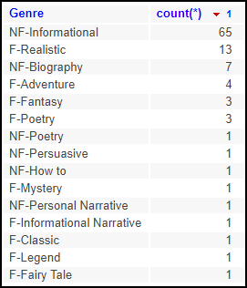

Top genres for all level u books

#### 

#### Themes

A book can have zero or more themes out of the 24 available for editorial to select.

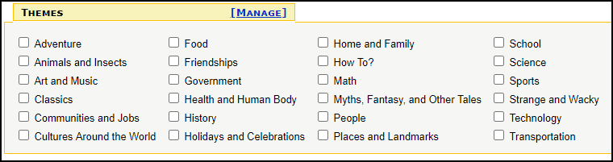

The 24 available themes editorial can set on a book

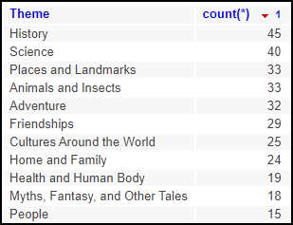

Top themes for all level u books

### Generic Results

In the cases where we cannot find any results from the search string or construct a set of recommended books for the student based on the student’s history there needs to be a catch-all display. This could be a message such as, “No results found, but check out the popular books above!” or display of another set of books that are irrespective of student.

## **Reach Goals**

* Autocompletesuggested search terms, similar to that of RAZ-Plus search autocomplete suggestions.
* Determine similar keywords or search terms that would be used to find books in our system similar to the searched string. Possibly by querying an outside API for similar keywords to the search string.
* Implement a way for Intermediate students to filter the returned results. Possibly by lexile, skills, book type, etc.
* The recommended books that are returned when there are no results could be weighted using multiple properties (both theme and genre).
* When a search is performed on RAZ-Plus and there are no results, a list of “Hot Search Topics” is returned. A similar feature could be implemented in the reading room, where popular search terms are used to find a set of generic recommended books, in the case that no tailored recommendations are found
  + One benefit of this method is that the returned books would vary based on current trends and events, such as holidays and seasons.
  + We would also need to filter the list of words in order to prevent somebody from spamming an inappropriate word.
* Could develop the list of recommendations as its own feature and always display them in the Reading Room.
* Increase the number of results with scrollability.